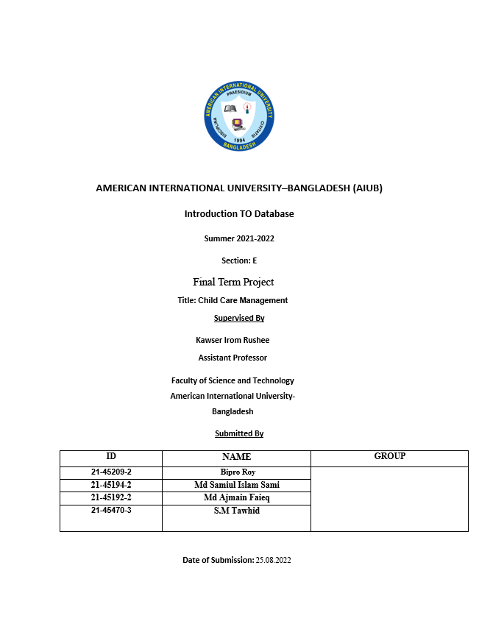

**Child Care Management**

**Case Study:**

ER diagram represents mainly Four entities: Parents, Child, babysitter, and class. Parents entity contains 5 main attributes P_Id, P_name, P_Phone, Location and occupation. Here P_Id is the primary key and P_Phone is multi values which attribute means attribute may have more than one value associated with the key and name. Location attribute consists of sub-attributes L_ID, City, Division. Parents entity shows one to many relations with child entity means 1 parents can have more than one child or one child also. Child entity consists CH_name, CH_ID, Age attributes. Here CH_ID is the primary key that helps in unique value filtration and joining of two columns. Dimond's shape explained the relationship between two entities. In the above ER Diagram Child entity is connected with two other entities one is with class and another one with a babysitter, with it shows that one or many children go to one class and one babysitter takes care of one or more child. In a Babysitter, the entity consists of four main attributes BS_ID, BS_Name, Salary, BS_Phone. Here BS_ID is primary key and BS_Phone is multivalued attribute. In class entity, it includes two attributes one C_ID and a C_name here C_ID is the primary key. Between class and babysitter entity shows one relationship means one class has only one Babysitter.

.

ER DIAGRAM STARTING TIME:

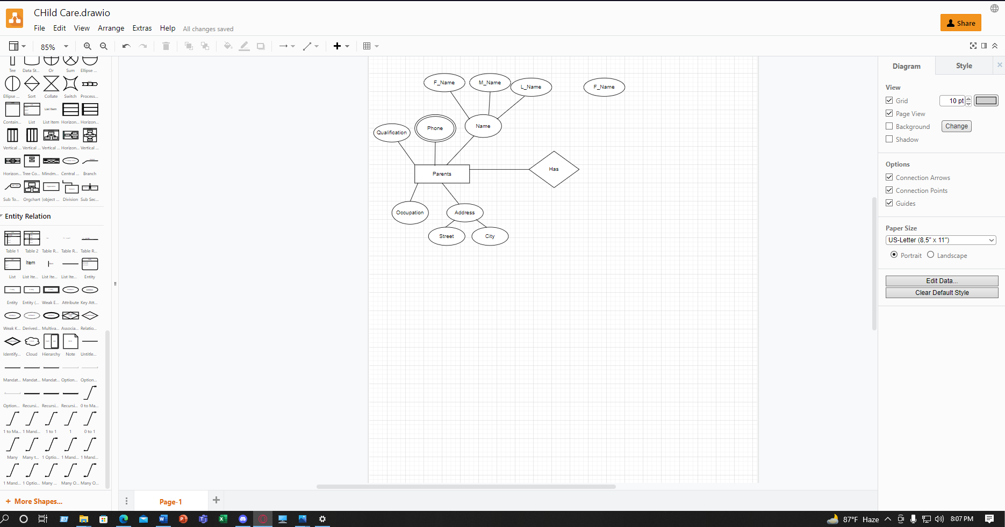

ER DIAGRAM ENDING TIME:

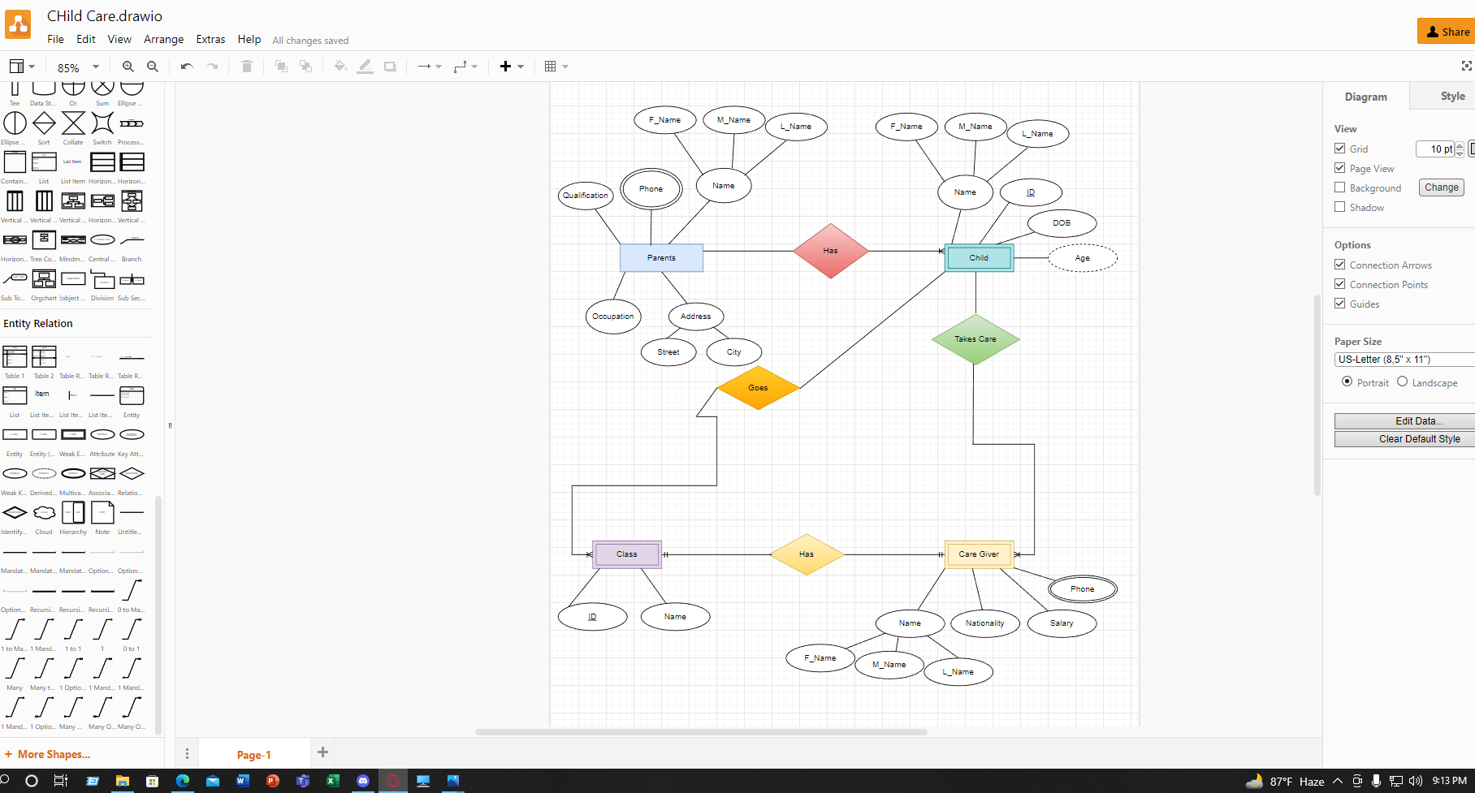

**ER-DIAGRAM OF MID-TERM:**

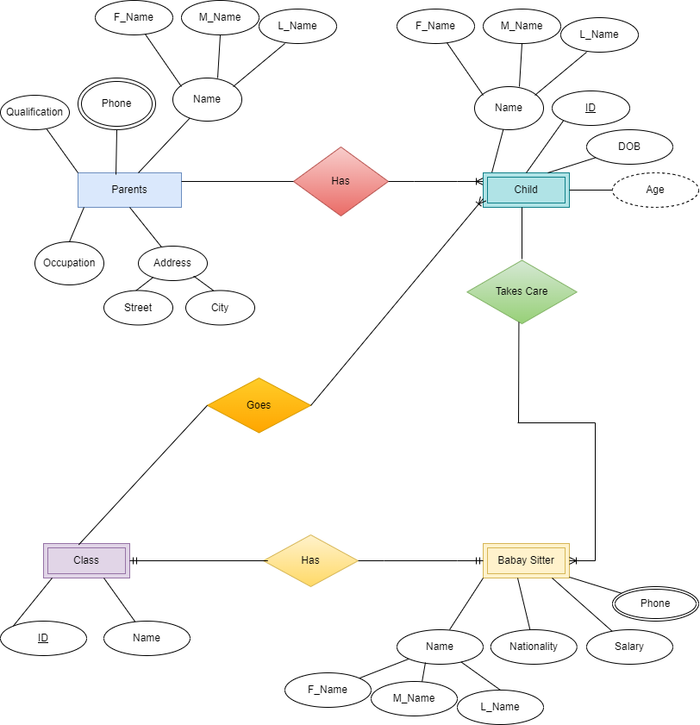

**Changes of ER-Diagram after Midterm :**

* Changed some Attributes for simplify
* Added Composite Attribute Division and Location Id in Location , Parents Id in Parents Entity , Babysitter Id in Babysitter Entity
* Removed DOB , Qualification, Nationality and Some Composite Attributes
* Defined Clearly Cardinality Relation In ER_Diagram

**Final ER Diagram**

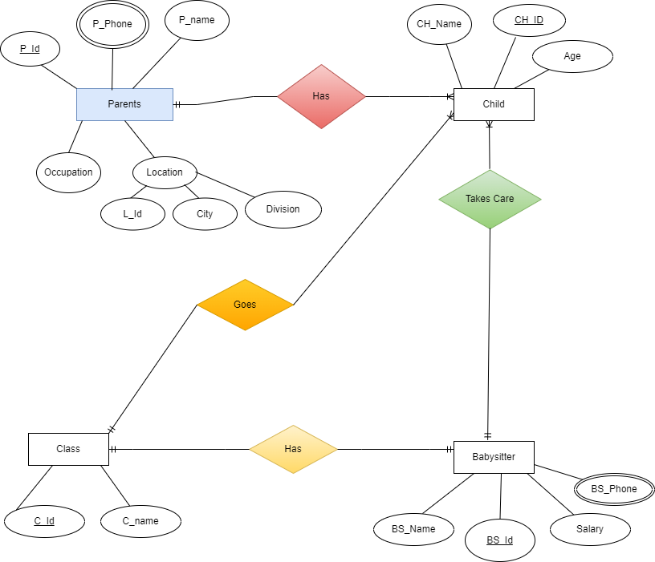

**Normalization**

*Has Relation: ( 1st )*

Parents ( P_ID, Pname, Occupation, L_ID, City, Division, P_Phone)

Child ( CH_ID, CH_name, Age)

**1NF:** P_ID, Pname, Occupation, L_ID, City, Division, P_Phone , CH_ID, CH_name, Age

**2NF:** 1st: P_ID, P_Phone, Pname, Occupation, L_ID, City, Division

2nd : CH_ID, CH_name, age, P_ID

**3NF:** 1st : P_ID, P_Phone, Pname, Occupation, L_ID

2nd : CH_ID, CH_name, age, P_ID

3rd : L_ID, City, Division

*Takes Care Relation:*

Child ( CH ID, CH_name, age)

BabySitter( Bs ID, Bs_name, Salary, Bs_Phone)

**1NF:** CH ID, CH_name, age, Bs ID, Bs_name, Salary, Bs_Phone

**2NF:**  1st : CH ID, CH_name, age, Bs_ID

2nd : Bs ID, Bs_Phone , Bs_name, Salary,

**3NF:** 1st : CH ID, CH_name, age, Bs_ID

2nd : Bs ID, Bs_Phone , Bs_name, Salary

*Has Relation: (2nd)*

Class ( C ID , C_name )

BabySitter( Bs ID, Bs_name, Salary, Bs_Phone)

**1NF:** C ID , C_name, Bs ID, Bs_name, Salary, Bs_Phone

**2NF :** 1st : C ID , C_name , Bs_ID

2nd : Bs ID, Bs_Phone , Bs_name, Salary

**3NF:** 1st : C ID , C_name , Bs_ID

2nd : Bs ID, Bs_Phone , Bs_name, Salary

*Goes Relation:*

Class ( C ID , C_name )

Child ( CH_ID, CH_name, age)

**1NF:** C ID , C_name , CH_ID, CH_name, age

**2NF:** 1st : C ID , C_name

2nd : CH_ID, CH_name, age, C_ID

**3NF:** 1st : C ID , C_name

2nd : CH_ID, CH_name, age, C_ID

**FINAL TABLE :**

**Parents:** P_ID, P_Phone , Pname, Occupation, L_ID

**Child_Parents :** CH_ID, CH_name, age, P_ID

**Location :** L_ID, City, Division

**BabySitter :** Bs ID, Bs_Phone, Bs_name, Salary

**Child_BabySitter :** CH ID, CH_name, age, Bs_ID

**Class :** C ID , C_name

**Class_BabySitter** : C ID , C_name , Bs_ID

**Child_Class :** CH_ID, CH_name, age, C_ID

**Table Creation With Constraints**

|  |  |  |
| --- | --- | --- |
| **Parents** | | |
| **Column Name** | **Data type** | **Constraints** |
| P_Id | Number(5) | Primary Key |
| P_Phone | Varchar2(11) | Unique |
| P_Name | Varchar2(30) | Not Null |
| Occupation | Varchar2(21) | Not Null |
| L_Id | Number (5) | Not Null |

**Create Table Parents (P_Id Number(5) CONSTRAINT pidpk PRIMARY KEY,**

**P_Name VARCHAR2(30) CONSTRAINT pnmcons NOT NULL,**

**P_Phone Varchar2(11) CONSTRAINT phn NOT NULL,**

**Occupation Varchar2(21) Constraint Oc_con NOT NULL,**

**L_Id Number(5) Constraint lid NOT NULL,**

**CONSTRAINT Phn_Un UNIQUE(P_Phone));**

**DESC Parents;**

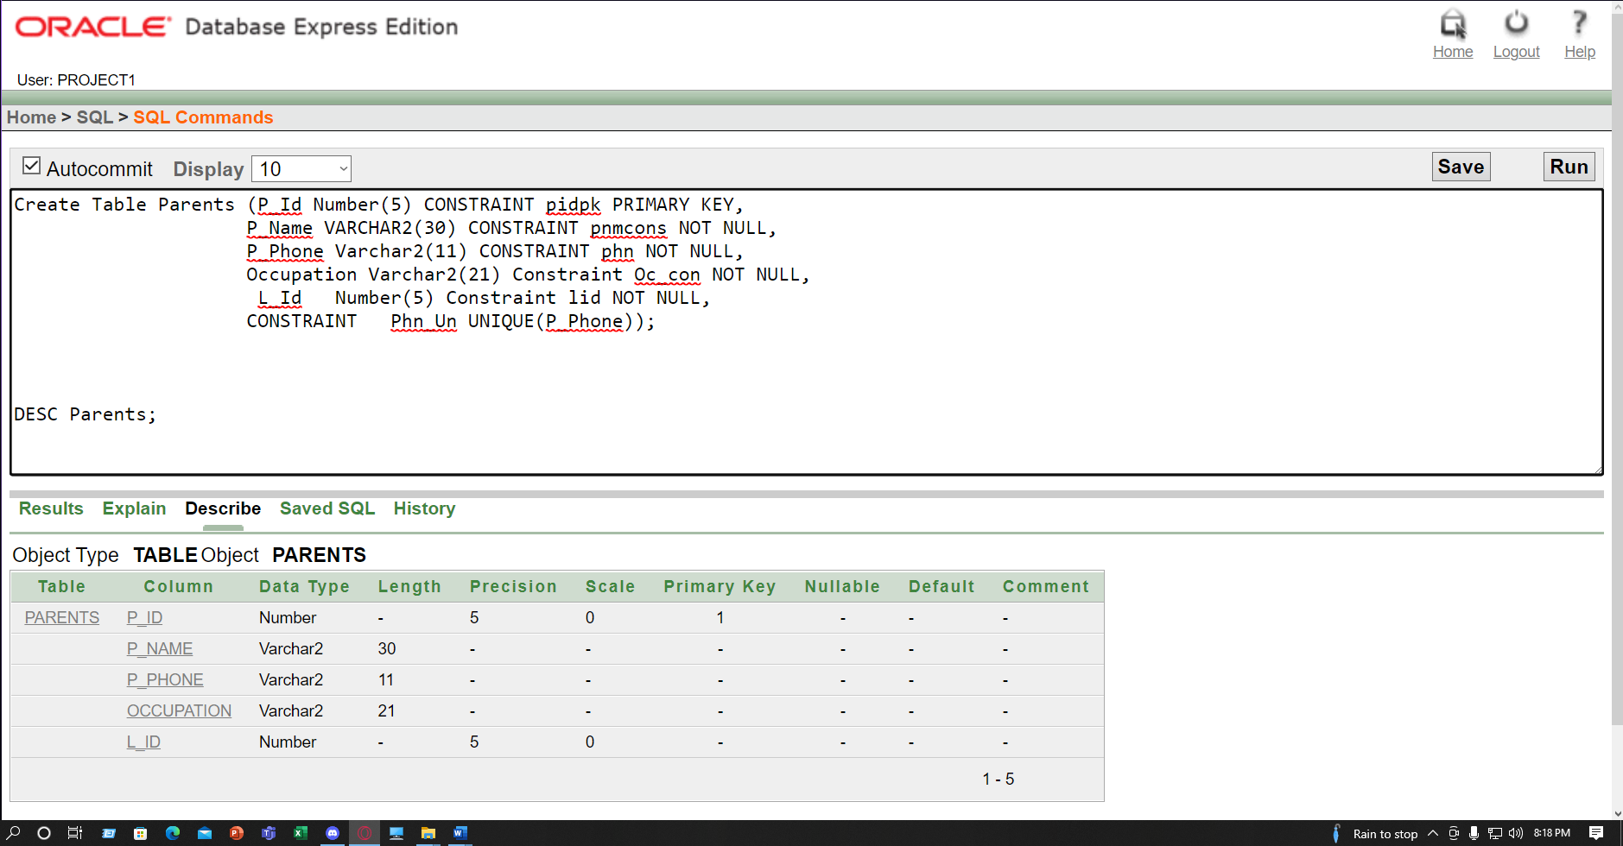

|  |  |  |
| --- | --- | --- |
| **Child_Parents** | | |
| **ColumnName** | **Data type** | **Constraints** |
| CH_Id | Number(5) | Primary Key |
| CH_Name | Varchar2(32) | NOT NULL |
| Age | Number(2) | NOT NULL |
| P_Id | Number(5) | Foreign Key |

**Create Table Child_Parents (CH_ID Number(5) CONSTRAINT chpk1 PRIMARY KEY, CH_Name Varchar2(32) Constraint chn2 NOT NULL,Age Number(2) Constraint agcon1 NOT NULL , P_Id number (5),**

**Constraint amm2 Foreign Key (P_Id) REFERENCES Parents(P_Id) );**

**DESC Child_Parents;**

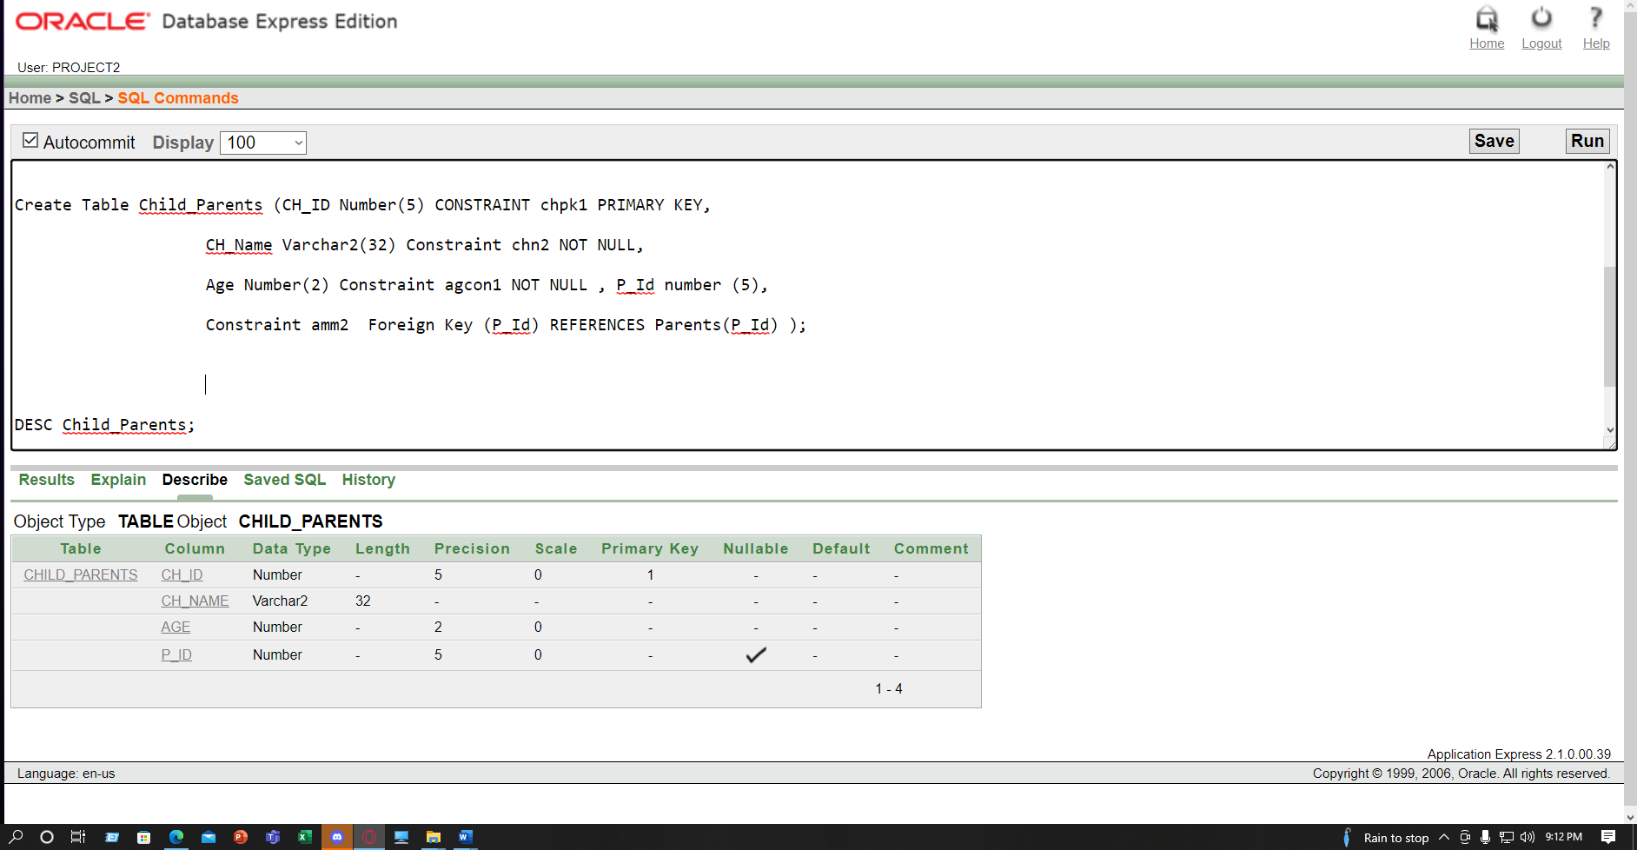

|  |  |  |
| --- | --- | --- |
| **Location** | | |
| **Column Name** | **Data type** | **Constraints** |
| L_Id | Varchar2(20) | Primary Key |
| City | Varchar2(20) |  |
| Division | Varchar2(20) | Not Null |

**Create Table Location(L_Id varchar2(20) constraint ldpk Primary Key,**

**City varchar2(20),**

**Division varchar2(20) constraint div Not Null);**

**DESC Location;**

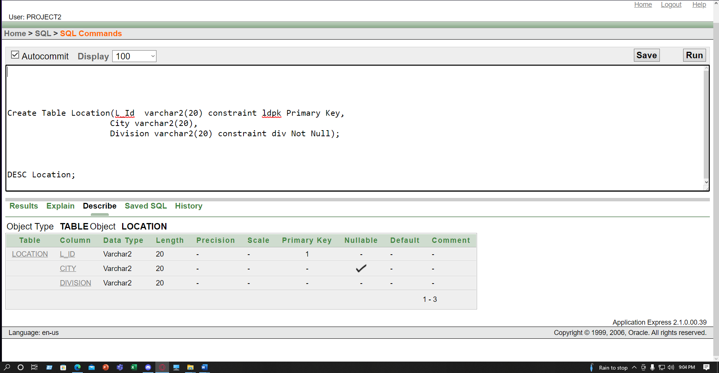

|  |  |  |
| --- | --- | --- |
| **Babysitter** | | |
| Column **Name** | **Data type** | **Constraints** |
| BS_Id | Number (5) | Primary Key |
| BS_Phone | Varchar2(11) | Unique |
| BS_Name | Varchar2(30) | Not Null |
| Salary | Number(7) | Not Null |

**Create Table Babysitter( BS_Id number(5) constraint bspk PRIMARY KEY,**

**BS_Phone number(11) constraint bsp NOT NULL,**

**BS_Name varchar2(30) constraint bsn NOT NULL,**

**Salary number(7) constraint saln NOT NULL,**

**constraint bsp_con UNIQUE(BS_Phone) );**

**DESC Babysitter;**

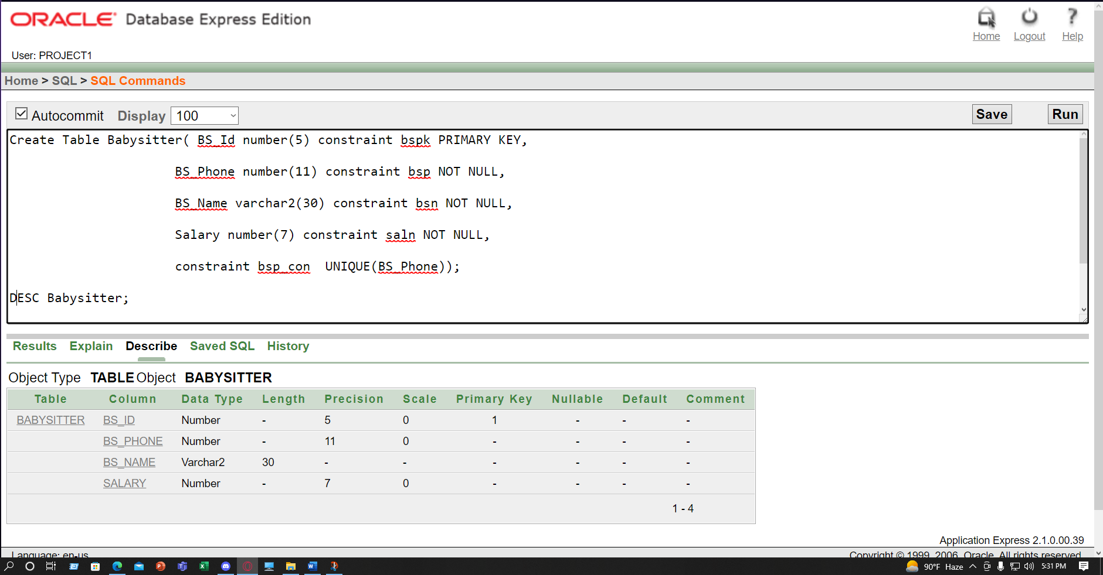

|  |  |  |
| --- | --- | --- |
| **Child_Babysitter** | | |
| Column **Name** | **Data type** | **Constraints** |
| CH_ID | Number(5) | Primary Key |
| CH_Name | Varchar2(30) | Not Null |
| Age | Varchar2(2) | Not Null |
| BS_Id | Number (5) | Foreign Key |

**Create Table Child_Babysitter(CH_ID number(5) constraint chpk22 Primary Key,**

**CH_Name Varchar2(30) constraint chn21 Not Null,Age number(2) constraint ag212 Not Null ,Bs_Id number (5), Constraint anm22 Foreign Key (BS_Id) REFERENCES Babysitter(BS_Id) );**

**DESC Child_Babysitter;**

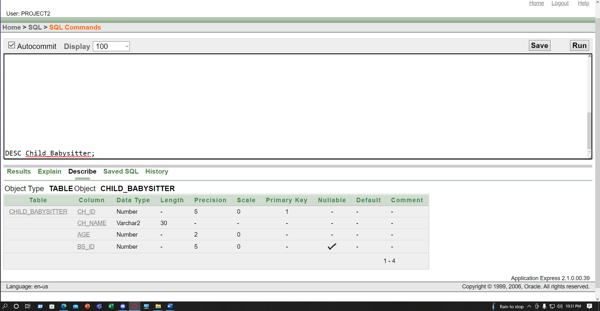

|  |  |  |
| --- | --- | --- |
| **Class** | | |
| Column **Name** | **Data type** | **Constraints** |
| C_Id | Number(5) | Primary Key |
| C_Name | Varchar2(10) | Not NULL |

**Create Table Class( C_Id number(5) constraint clpk PRIMARY KEY,**

**C_Name varchar(10) constraint cln NOT NULL );**

**DESC Class;**

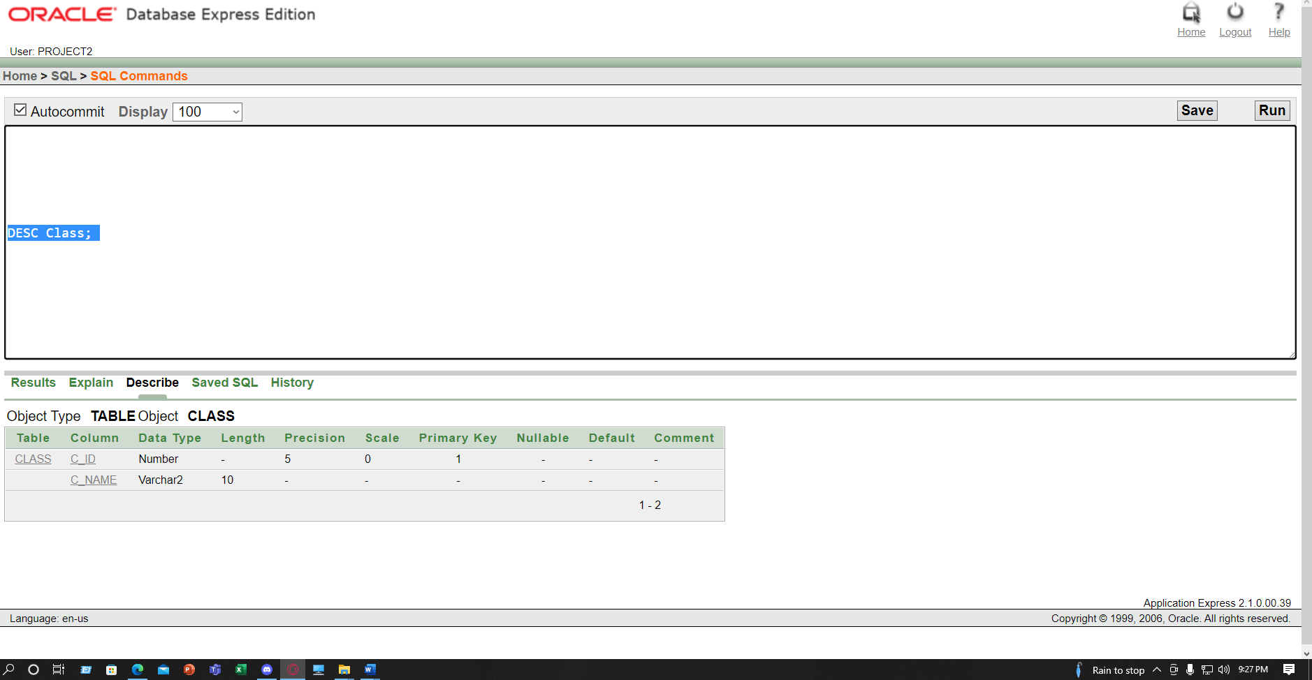

|  |  |  |
| --- | --- | --- |
| **Class_Babysitter** | | |
| Column **Name** | **Data type** | **Constraints** |
| C_Id | Number(5) | Primary Key |
| C_Name | Varchar2(10) | Not Null |
| BS_Id | Number(5) | Foreign Key |

**Create Table Class_Babysitter( C_Id number(5) constraint cdi11 Primary Key, C_Name varchar2(10) constraint cnam22 Not Null ,BS_Id number(5),**

**Constraint bsid20 Foreign Key(BS_Id) REFERENCES Babysitter(Bs_Id) );**

**DESC Class_Babysitter ;**

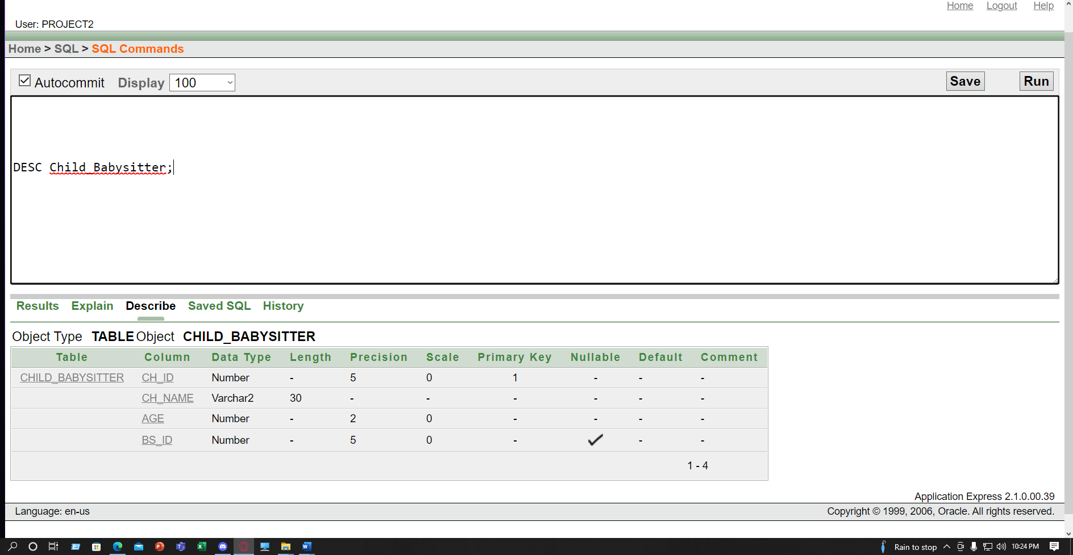

|  |  |  |
| --- | --- | --- |
| **Child_Class** | | |
| Column **Name** | **Data type** | **Constraints** |
| CH_Id | Number(5) | Primary Key |
| CH_Name | Varchar2(32) | Not Null |
| Age | Number (2) | Not Null |
| C_Id | Number(5) | Foreign Key |

**Create Table Child_Class ( CH_ID number(5) constraint chd32 primary key , CH_Name varchar2(32) Constraint chnm21 Not Null,Age number(2) Constraint ag32 Not Null,C_Id Number (5), Constraint cd232 Foreign Key(C_Id) REFERENCES Class (C_Id));**

**DESC Child_Class;**

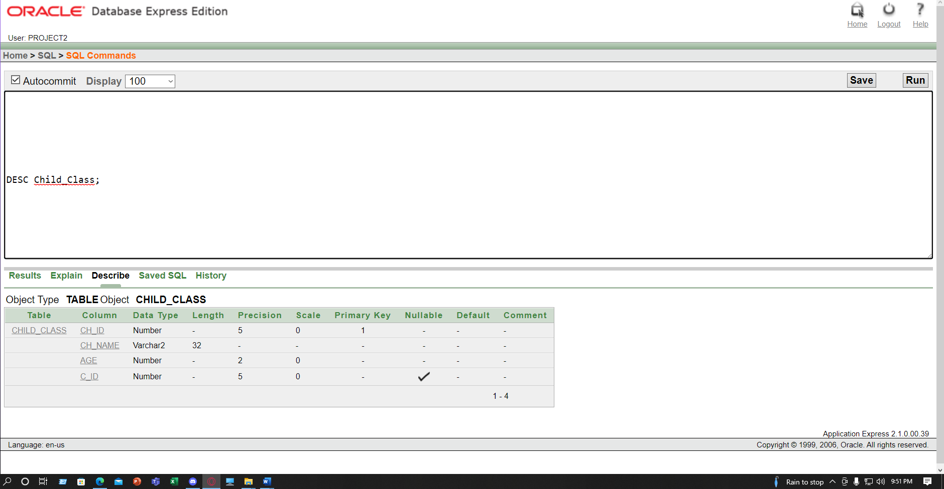

**Data Insertion:**

Table**: Parents**

INSERT INTO Parents VALUES (21451,'Jason Roy','01688354400','Businessman' ,12135 );

INSERT INTO Parents VALUES (21452,'Peter Parkur', '01688354411','Journalist' ,12146);

INSERT INTO Parents VALUES (21453, 'Marry Jen', '01688354422','Teacher' ,12156 );

INSERT INTO Parents VALUES (21454,'Osborn Harry','01688354433','Engineer' , 12167);

INSERT INTO Parents VALUES (21455, 'Octavius', '01688354444','Doctor' ,12178 );

INSERT INTO Parents VALUES (21456,'Frankestine','01688354466','Engineer' ,12198);

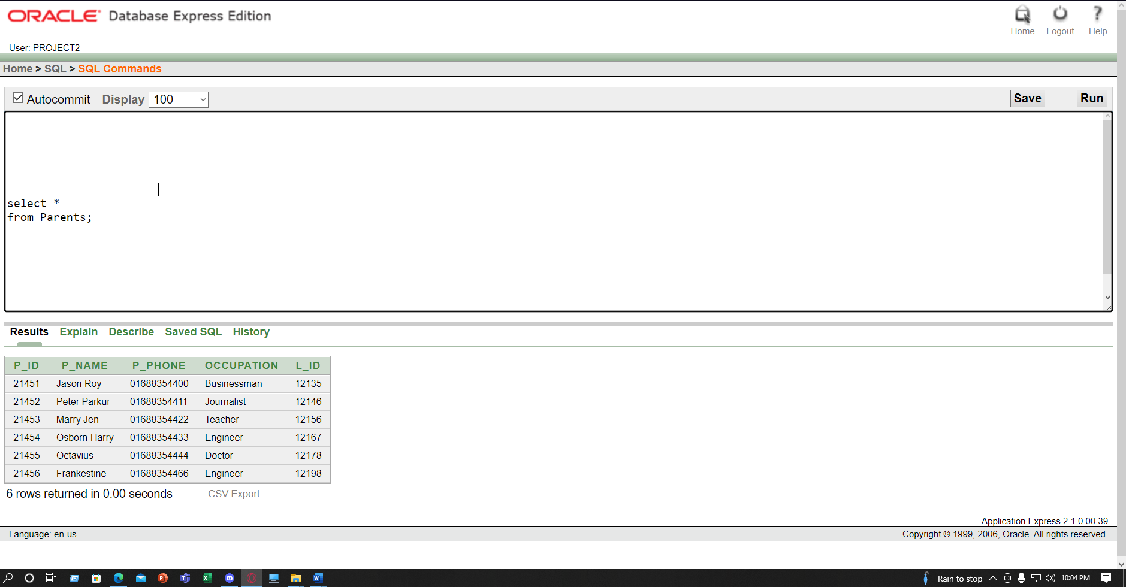

Table : **Child_Parents**

INSERT INTO Child_Parents VALUES (20451, 'Richard',6 , 21451 );

INSERT INTO Child_Parents VALUES (20452, 'Philip',8 , 21452 );

INSERT INTO Child_Parents VALUES (20453, 'Miles',9 , 21452 );

INSERT INTO Child_Parents VALUES (20454, 'Dapr',6, 21453);

INSERT INTO Child_Parents VALUES (20455, 'Shroud',7, 21454 );

INSERT INTO Child_Parents VALUES (20456, 'Tenz',10, 21455);

INSERT INTO Child_Parents VALUES (20457, 'Zellsis',9, 21456 );

INSERT INTO Child_Parents VALUES (20458, 'Zombs',9, 21456);

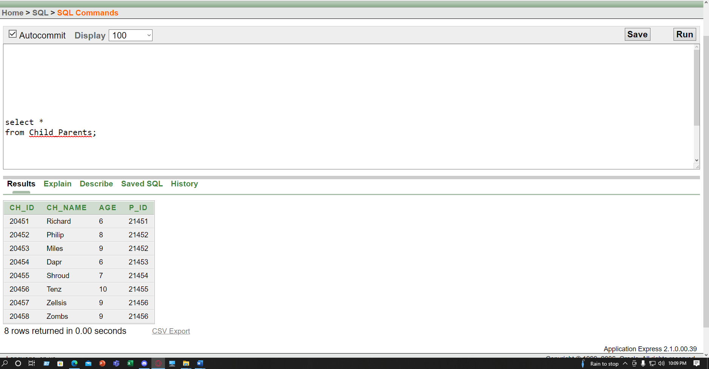

Table:**Location**

INSERT INTO Location VALUES (12135, 'Banani','Dhaka');

INSERT INTO Location VALUES (12146, 'Tejgaon','Dhaka');

INSERT INTO Location VALUES (12156, 'Sylhet','Sylhet');

INSERT INTO Location VALUES (12167 , 'Khulna','Khulna');

INSERT INTO Location VALUES (12178, 'Barisal','Barisal');

INSERT INTO Location VALUES (12198, 'Rajshahi','Rajshahi' );

INSERT INTO Location VALUES (12111, 'Noakhali','Chittagong' );

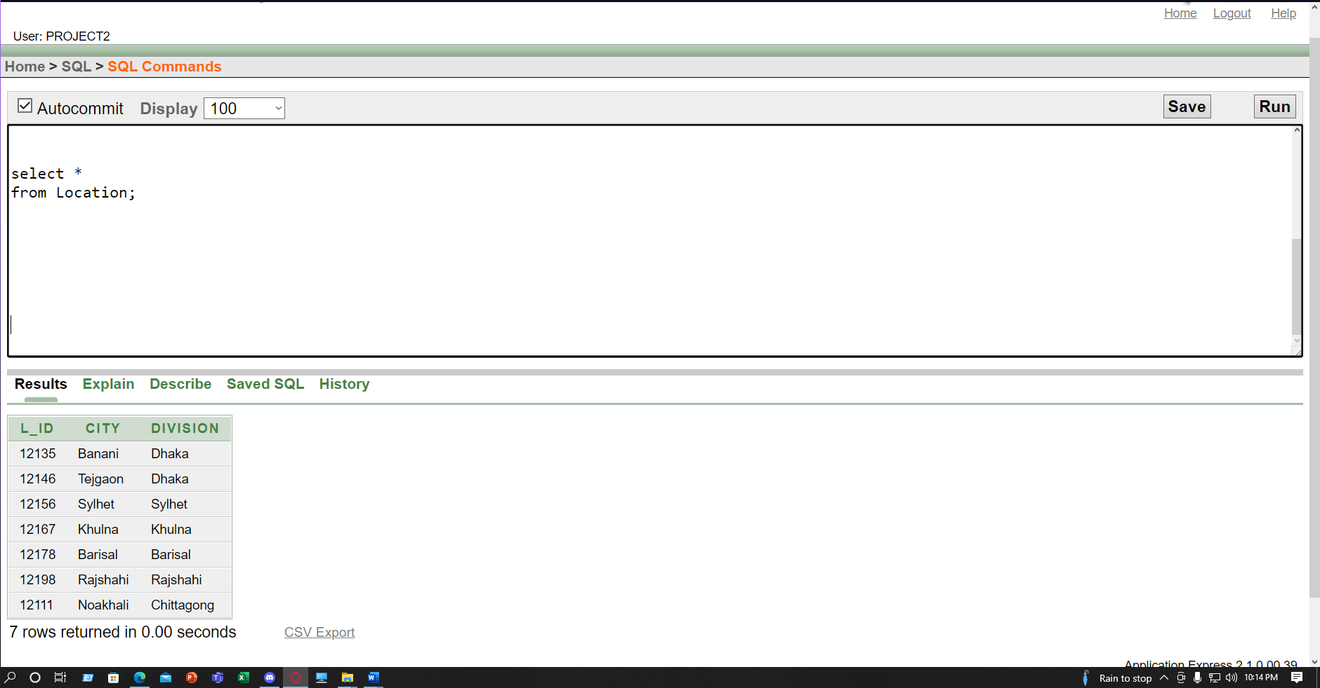

Table: **Babysitter**

INSERT INTO Babysitter VALUES (10451, '01715023511','Sophia' ,50000 );

INSERT INTO Babysitter VALUES (10452, '01715023522','Evelyn' ,30000 );

INSERT INTO Babysitter VALUES (10453, '01715023533','Luna' ,21000 );

INSERT INTO Babysitter VALUES (10454, '01715023544','Elizabeth' ,40000);

INSERT INTO Babysitter VALUES (10455, '01715023555','Mila' ,35000 );

INSERT INTO Babysitter VALUES (10456, '01715023566','Sofel' ,35000 );

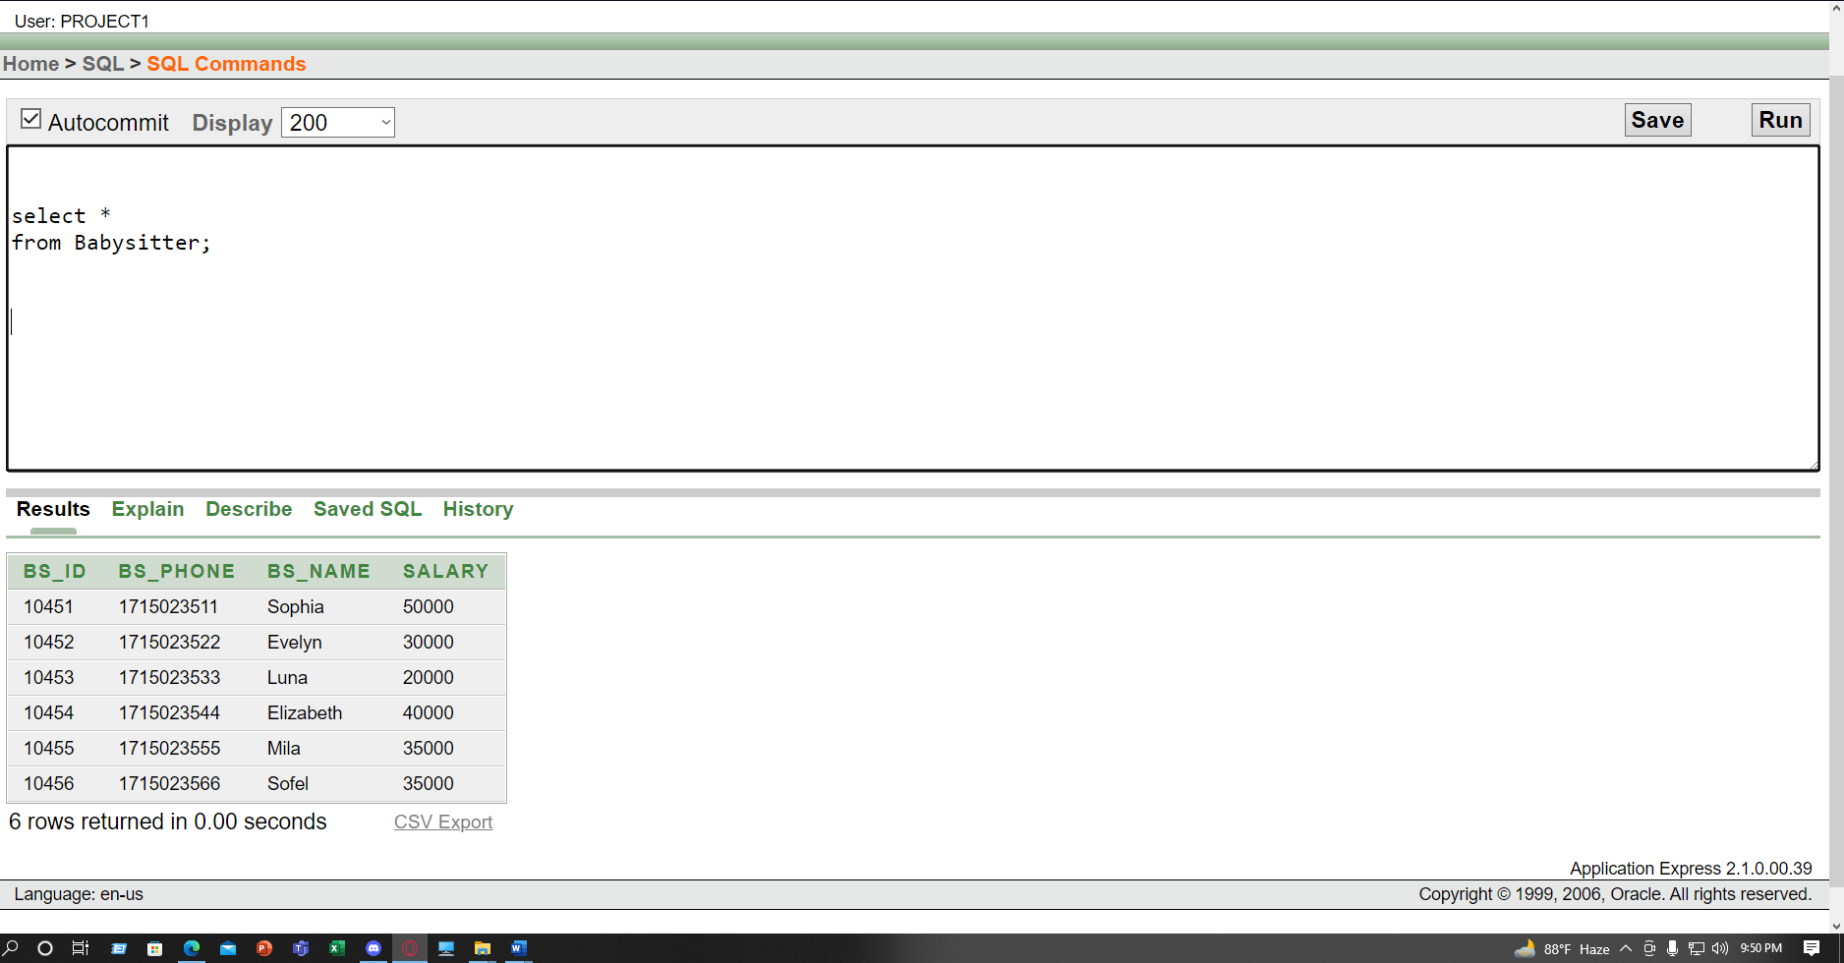

Table**: Child_Babysitter**

INSERT INTO Child_Babysitter VALUES (20451, 'Richard',6 , 10451);

INSERT INTO Child_Babysitter VALUES ( 20452, 'Philip',8 , 10451);

INSERT INTO Child_Babysitter VALUES (20453, 'Miles',9 , 10452);

INSERT INTO Child_Babysitter VALUES (20454, 'Dapr',6, 10452);

INSERT INTO Child_Babysitter VALUES (20455, 'Shroud',7, 10453);

INSERT INTO Child_Babysitter VALUES (20456, 'Tenz',10, 10453);

INSERT INTO Child_Babysitter VALUES (20457, 'Zellsis',9, 10454);

INSERT INTO Child_Babysitter VALUES (20458, 'Zombs',9, 10455);

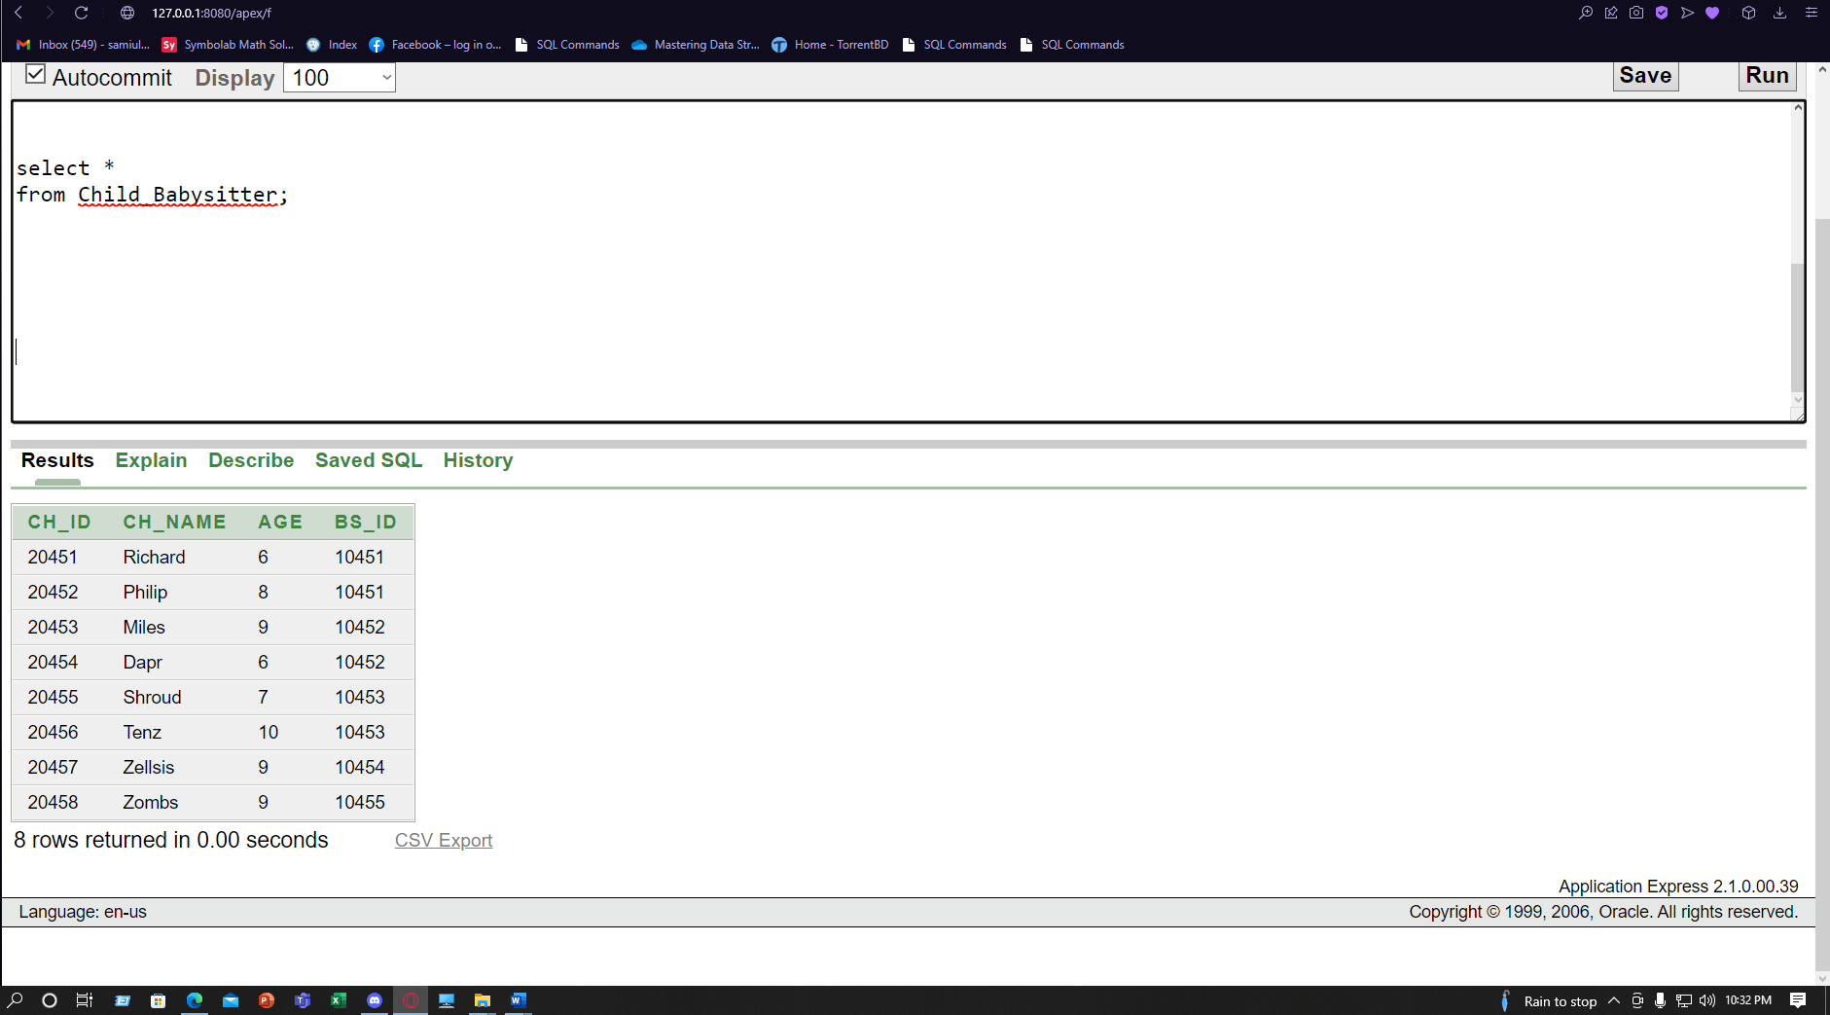

Table:**Class**

INSERT INTO Class VALUES (40451, 'Tiger');

INSERT INTO Class VALUES (40452, 'Lion');

INSERT INTO Class VALUES (40453, 'Lotus');

INSERT INTO Class VALUES (40454, 'Rose');

INSERT INTO Class VALUES (40455, 'Lily');

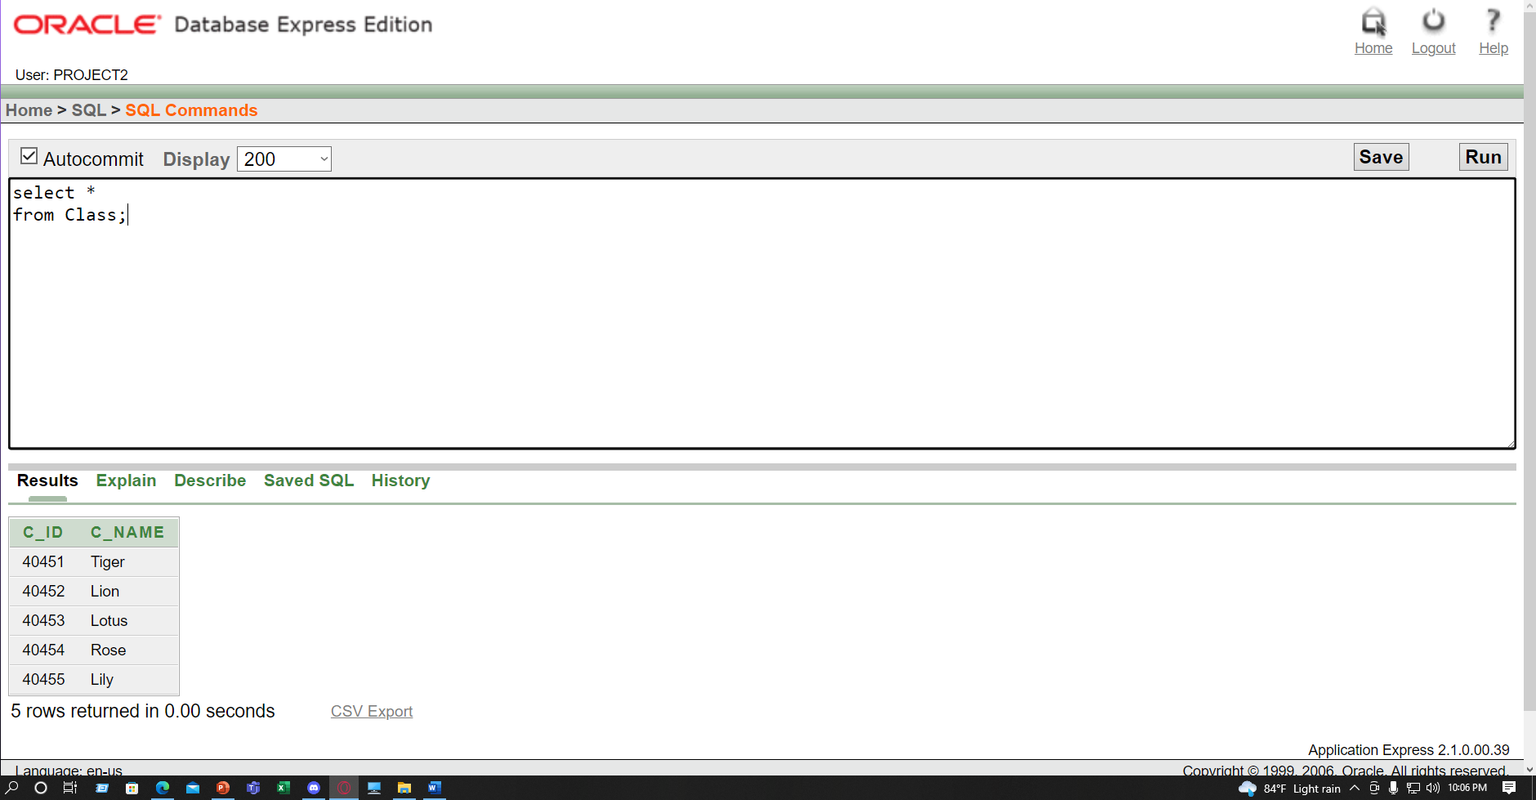

Table:**Class_Babysitter**

INSERT INTO Class_Babysitter VALUES (40451, 'Tiger',10451);

INSERT INTO Class_Babysitter VALUES (40452,'Lion',10452 );

INSERT INTO Class_Babysitter VALUES (40453, 'Lotus',10453 );

INSERT INTO Class_Babysitter VALUES (40454,'Rose',10454 );

INSERT INTO Class_Babysitter VALUES (40455, 'Lily',10455 );

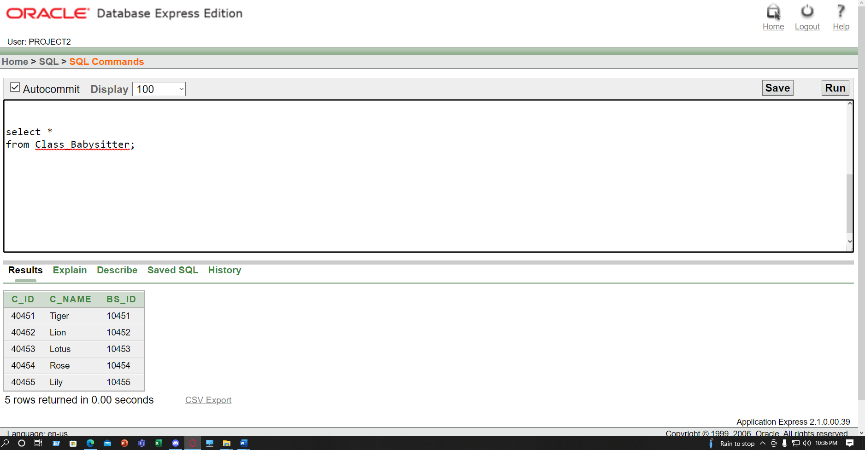

Table: **Child_Class**

INSERT INTO Child_Class VALUES (20451, 'Richard',6 , 40451);

INSERT INTO Child_Class VALUES (20452, 'Philip',8 , 40451);

INSERT INTO Child_Class VALUES (20453, 'Miles',9 ,40452);

INSERT INTO Child_Class VALUES (20454, 'Dapr',6, 40452);

INSERT INTO Child_Class VALUES (20455, 'Shroud',7, 40453);

INSERT INTO Child_Class VALUES (20456, 'Tenz',10, 40453);

INSERT INTO Child_Class VALUES (20457, 'Zellsis',9, 40454);

INSERT INTO Child_Class VALUES (20458, 'Zombs',9,40455);

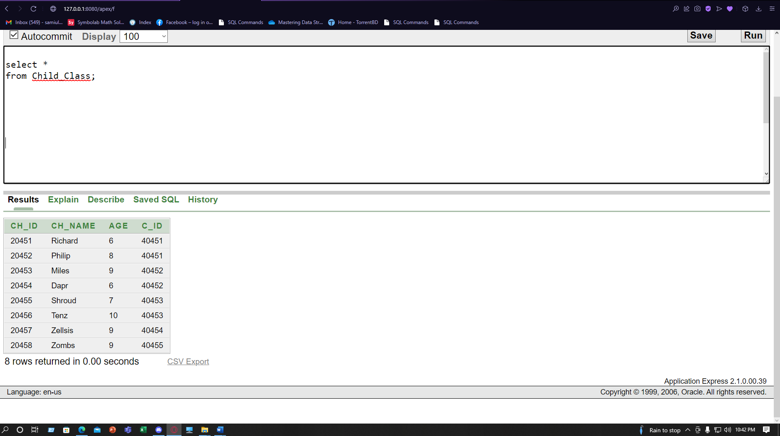

Joining**: Equijoin**

* **Show Babysitter information who are assigned with Class and Show also Class Name?**

select bs.*,cl.C_Name

from Babysitter bs, Class cl ,Class_Babysitter

where bs.BS_Id = Class_Babysitter .BS_Id and cl.C_Id = Class_Babysitter .C_Id;

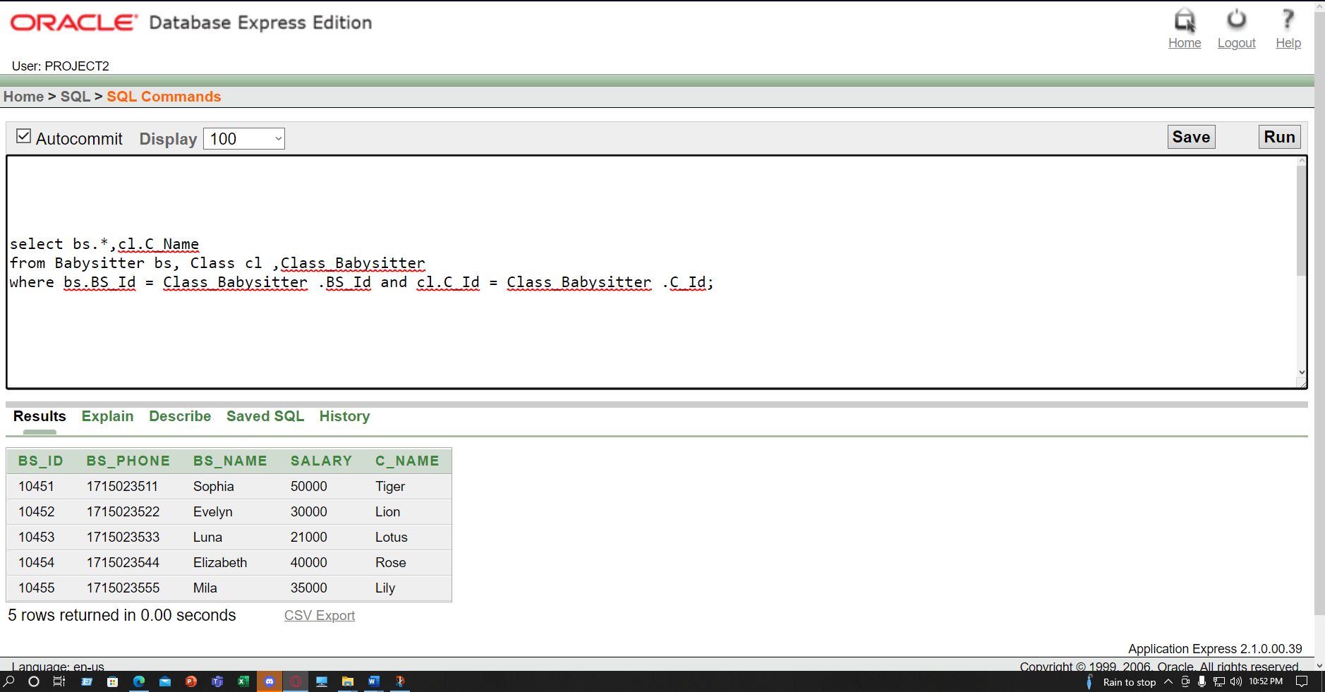

Joining**: Equijoin**

* **Show Parents Information who are in Dhaka Division?**

select p.*,l.Division

from Parents p,Location l

where p.L_Id =l.L_Id and l.Division='Dhaka' ;

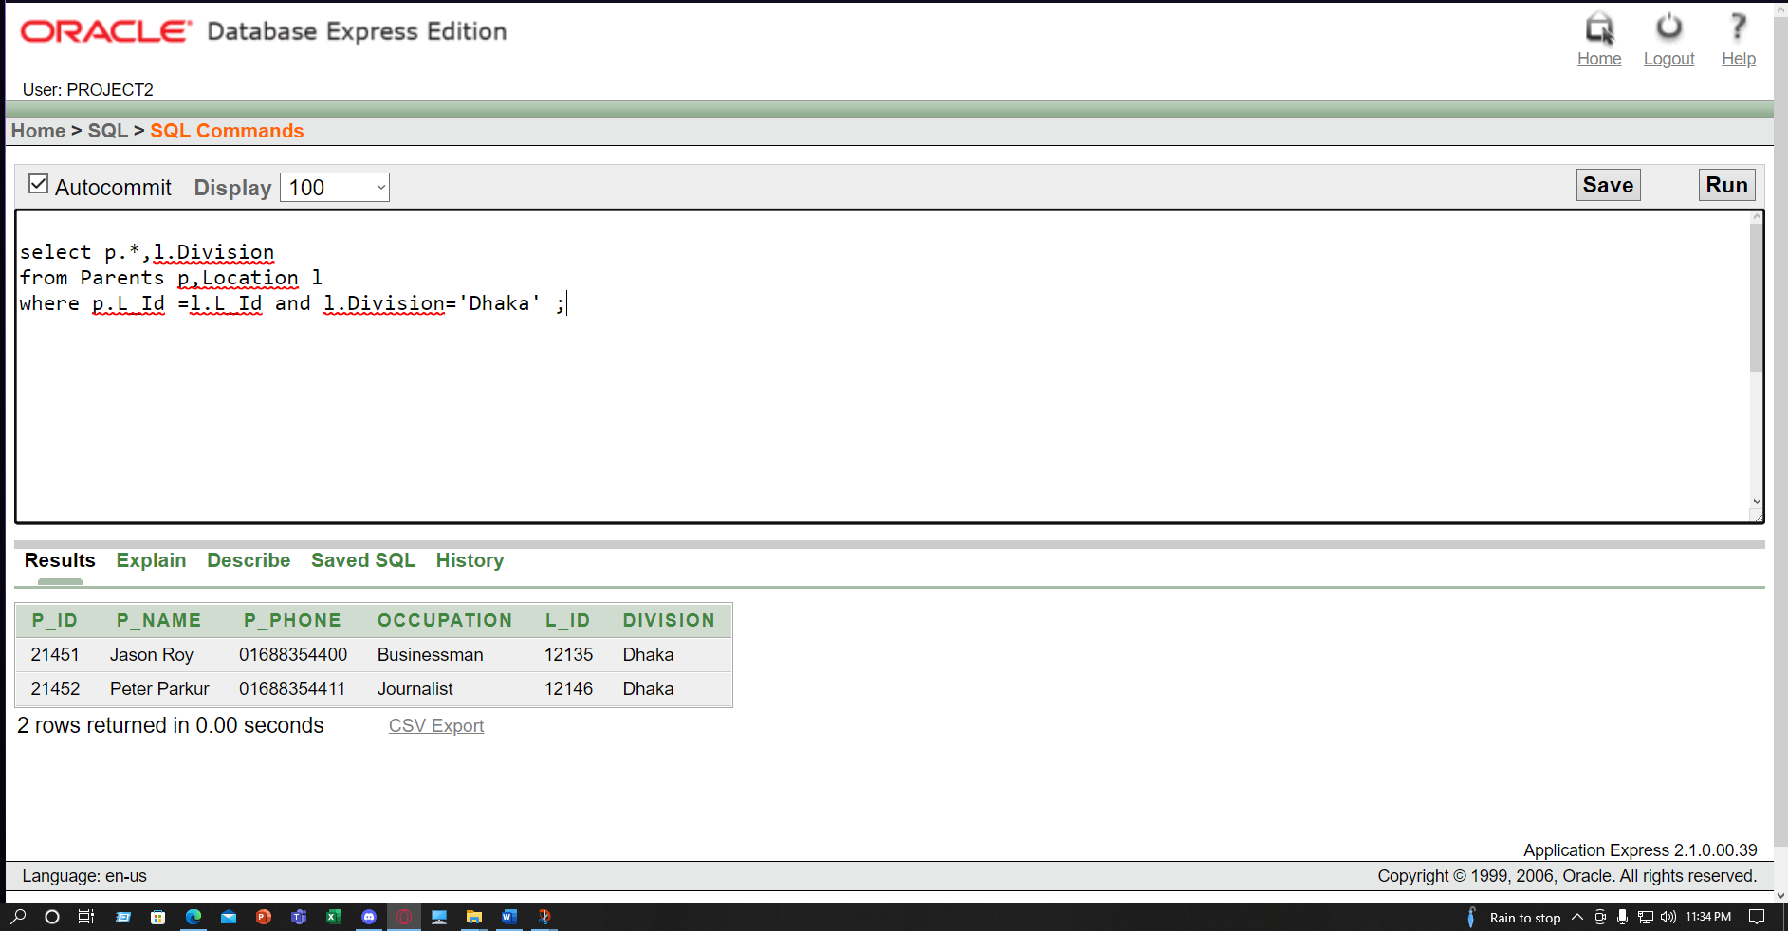

Joining: **Outer join**

* **Show Parents Id,Name,Phone Location-wise ?**

**select p.*,l.Division**

**from Parents p,Location l**

**where p.L_Id (+) = l.L_Id;**

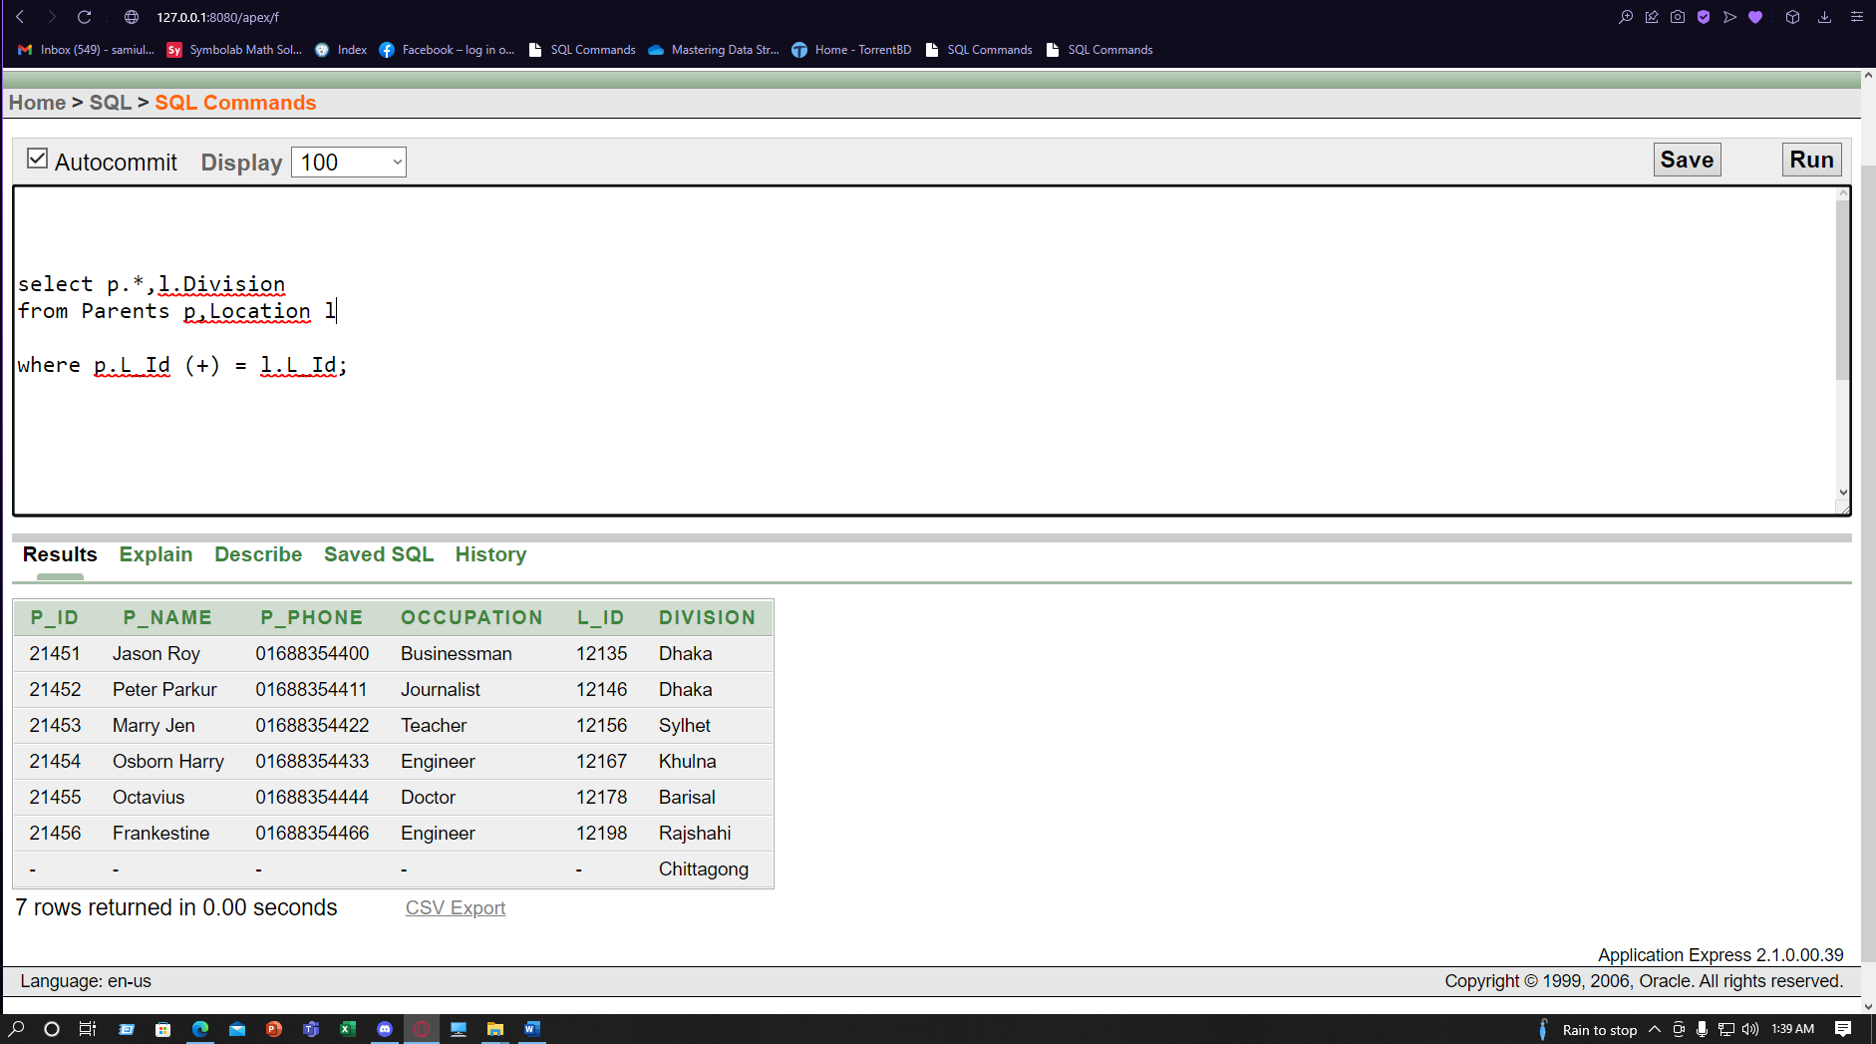

Joining: **Outer join**

* **Show Class Information and Show all Babysitter Name ,Id**

select c.*,bs.BS_Name,bs.BS_Id

from Class c, Class_Babysitter bb , Babysitter bs

where c.C_Id (+) = bb.C_Id and bs.BS_Id = bb.BS_Id(+);

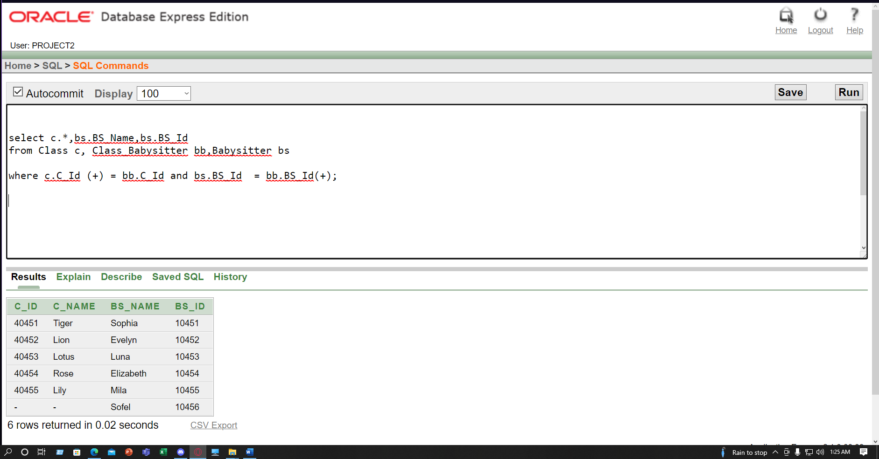

Joining: **Self Joining**

* **Show Location Information where City and Division is same**

select l.L_ID, l.City , s.Division

from Location l, Location s

where l.City = s.Division;

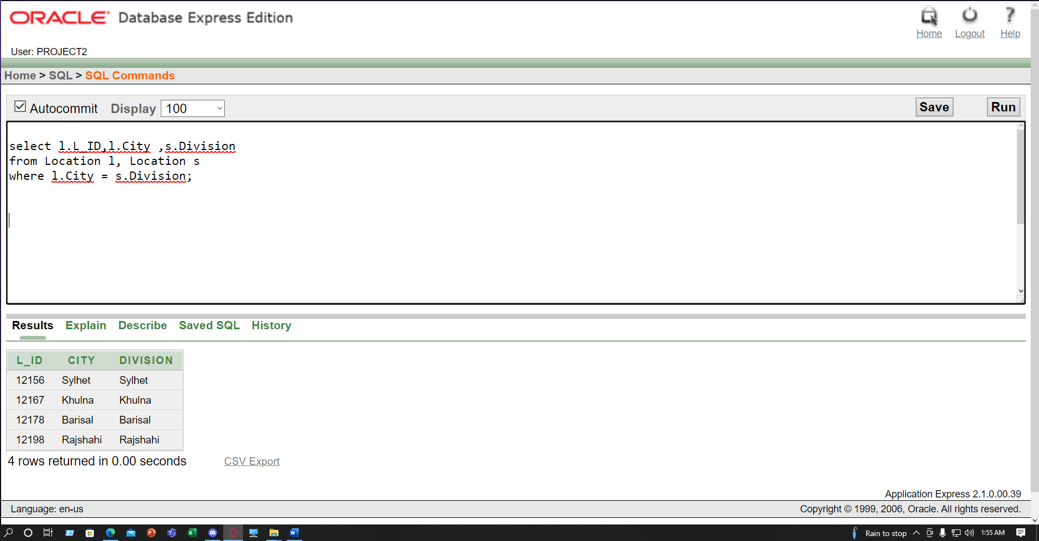

**Joining: Non-equijoin**

* **Show the Babysitter information where Babysitter's salary is between Child Id and Parents Id**

select distinct bs.*

from Babysitter bs,Parents p ,Child_Parents cp

where bs.Salary BETWEEN cp.CH_ID AND p.P_Id ;

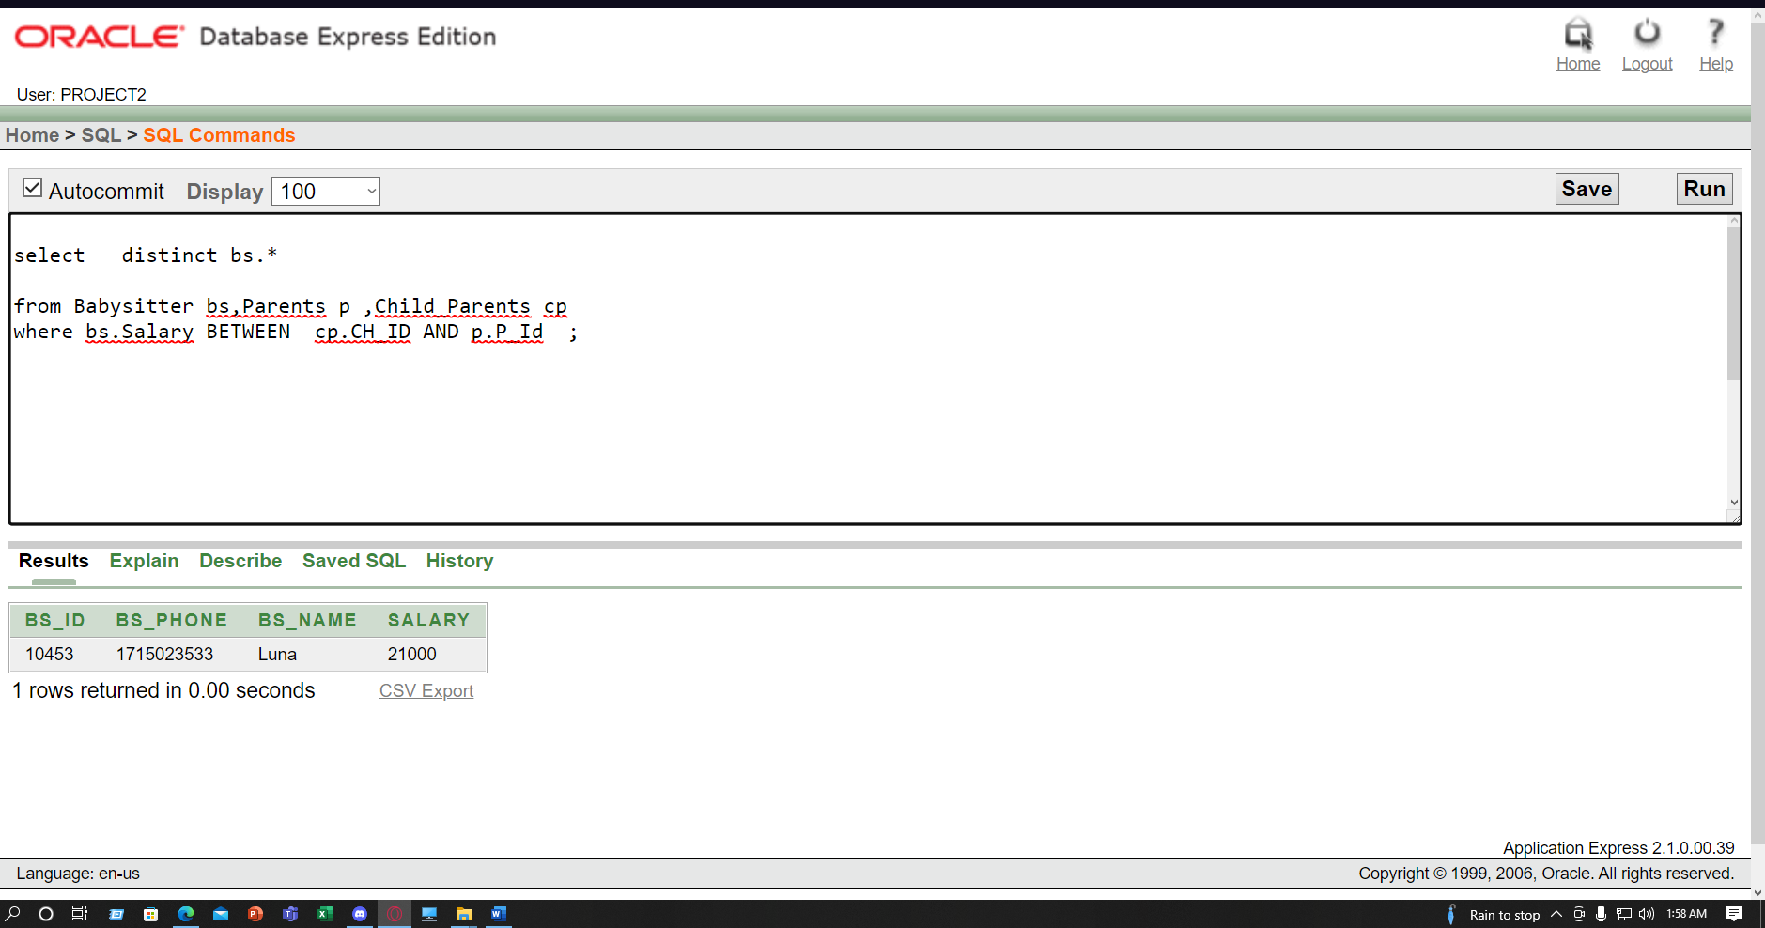

**Sub-query:**

* **Display All the child's Name whose age are greater than Shroud' Age?**

select *

from Child_Parents

where Age>All(select Age

from Child_Parents

where CH_Name='Shroud' );

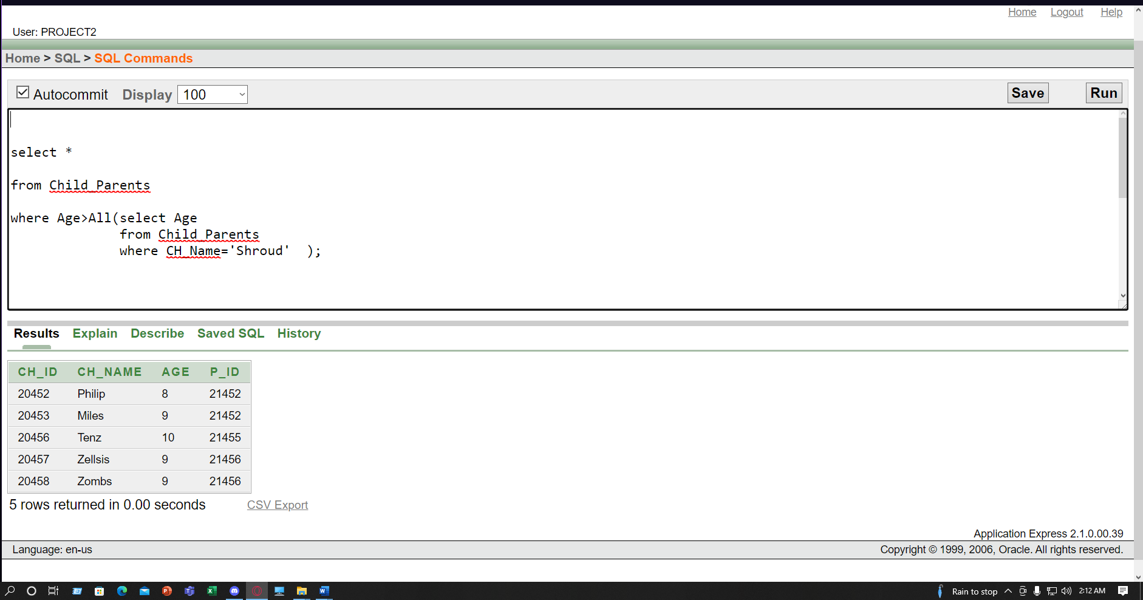

* **Show All the Parents information Who Stay in Dhaka Division?**

select *

from Parents

where L_Id in (select L_Id

from Location

where Division='Dhaka' );

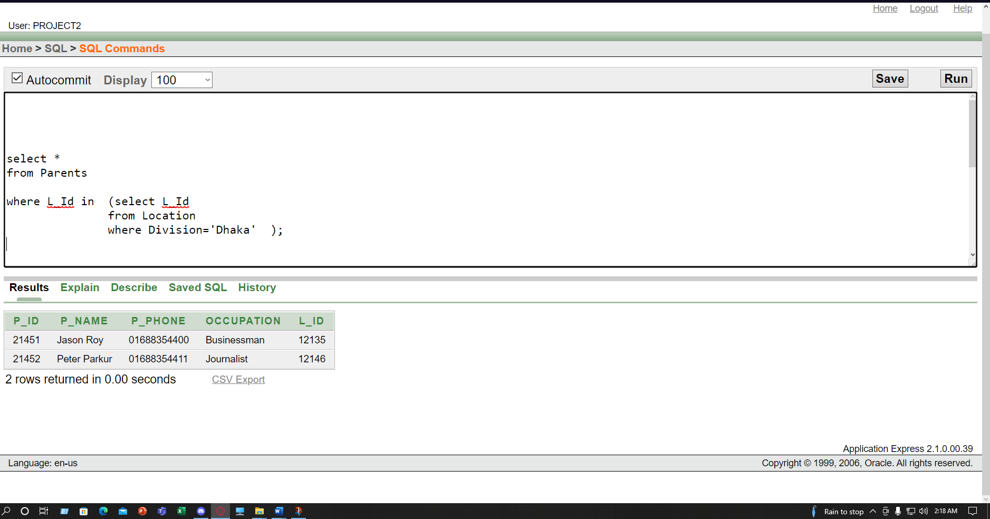

* **Display Maximum Salary of Babysitter**

select BS_Name,BS_Phone,Salary

from Babysitter

where Salary = (select Max(Salary)

from Babysitter);

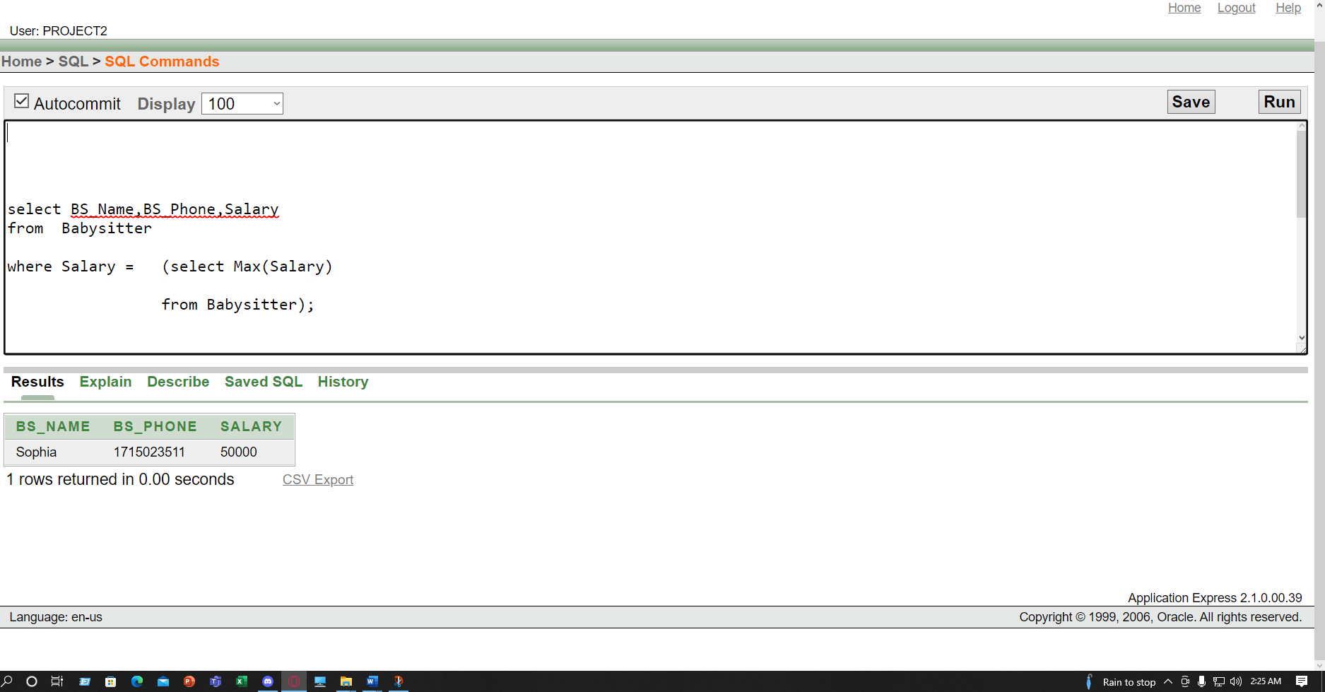

* **Show All Child's Name whose Age is greater than 8 and which Parents is Engineer**

select *

from Child_Parents

where Age>= 8 and P_Id in (select P_Id

from Parents

where Occupation='Engineer' );

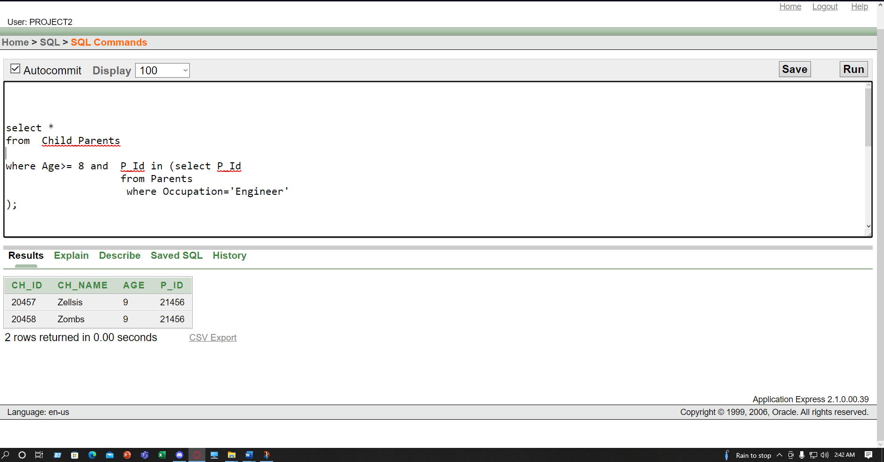

**Simple View:**

* **Create View All the child's Name whose age are Less than 9**

Create View child_9

As select CH_Name Child_Name , Age

from Child_Parents

where Age<9;

select *

from child_9;

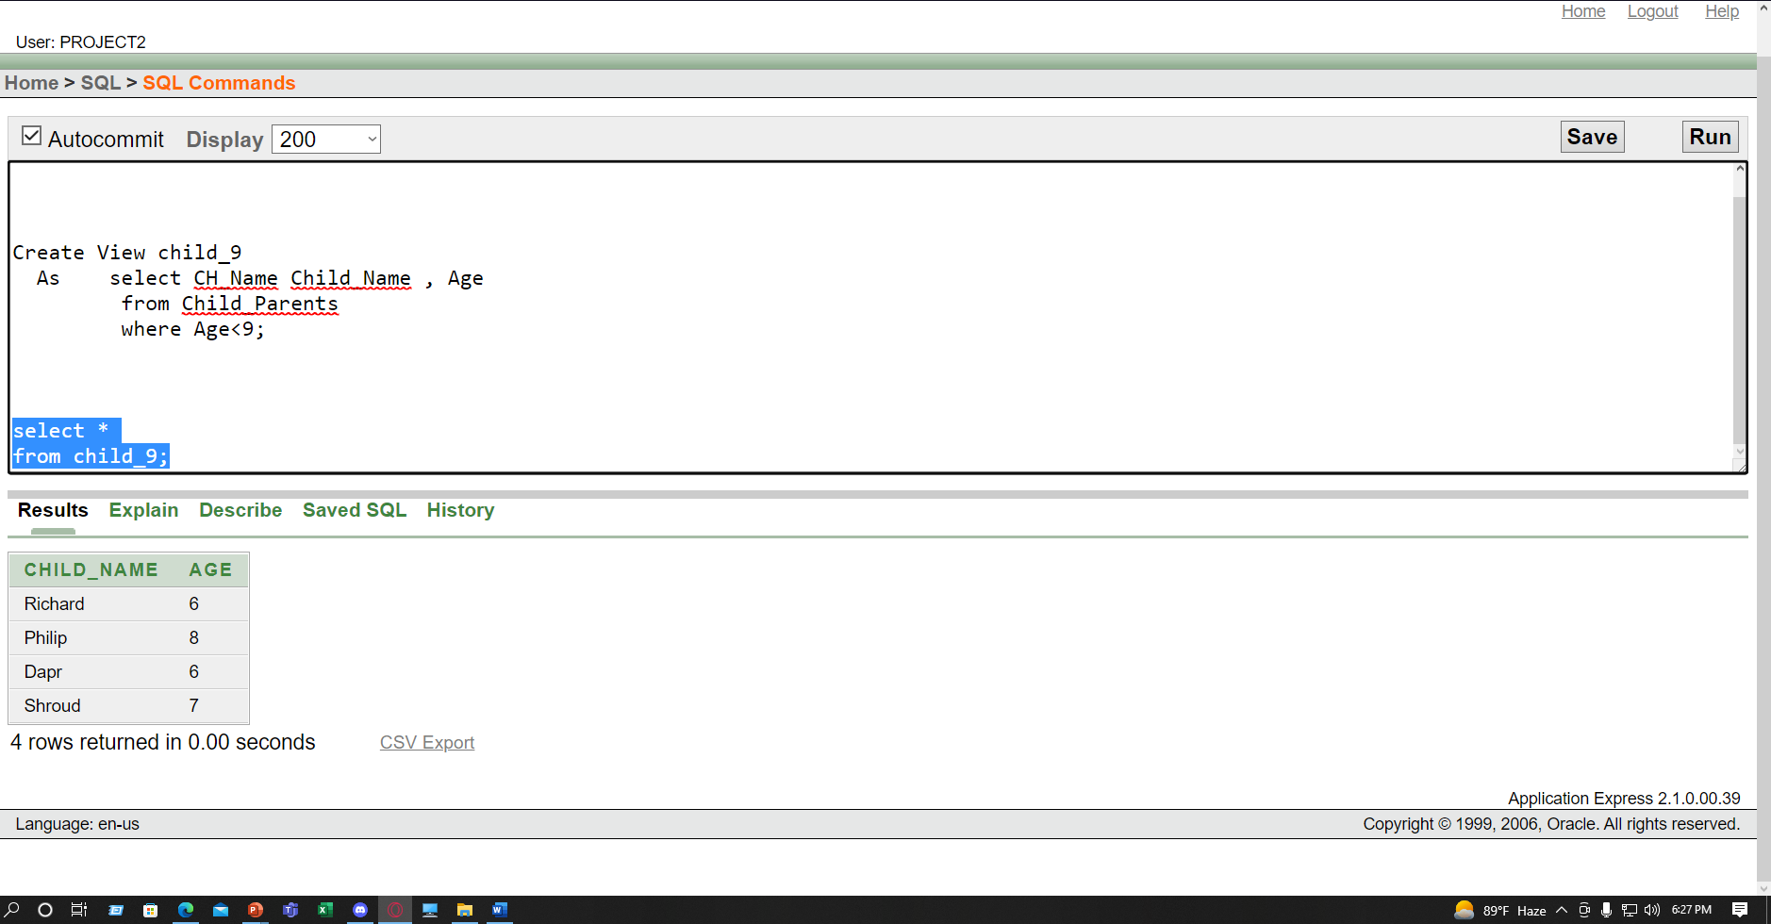

**Complex View:**

* **Show a view of number of Child Age-wise**

create or replace view child_count ("Child Age","Number of Child")

As select Age,count(CH_ID)

from Child_Class

group by Age;

select *

from child_count**;**

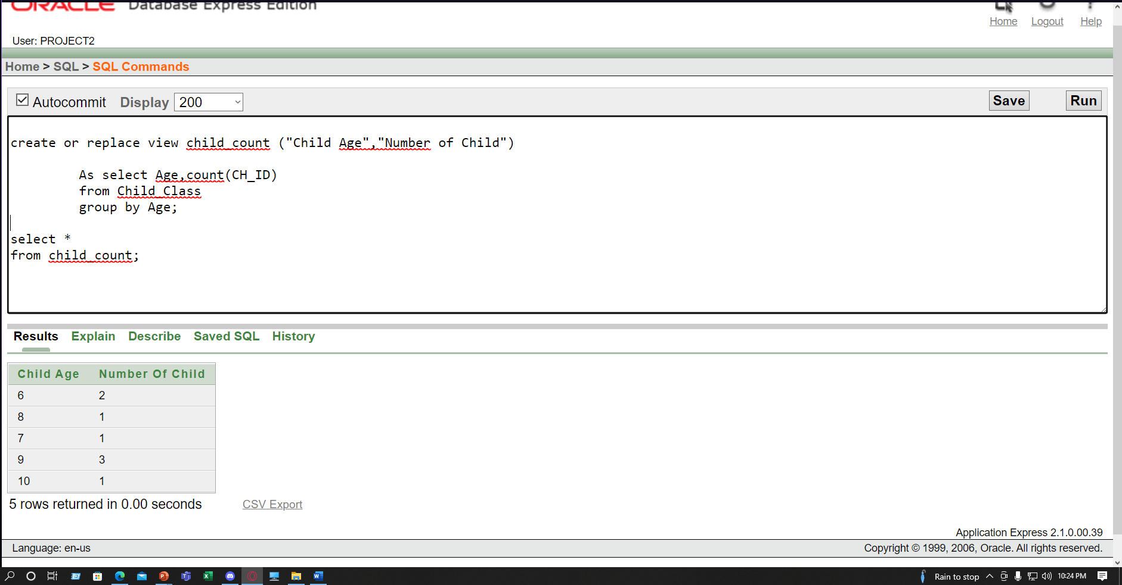

**Adding constraint in table**

* Constraint is already added in all tables but one additional constraint is added in Location table.

**Alter Table Location Modify City Not Null;**

